**Task Guide line**

**Step 1 – Create new Workspace**

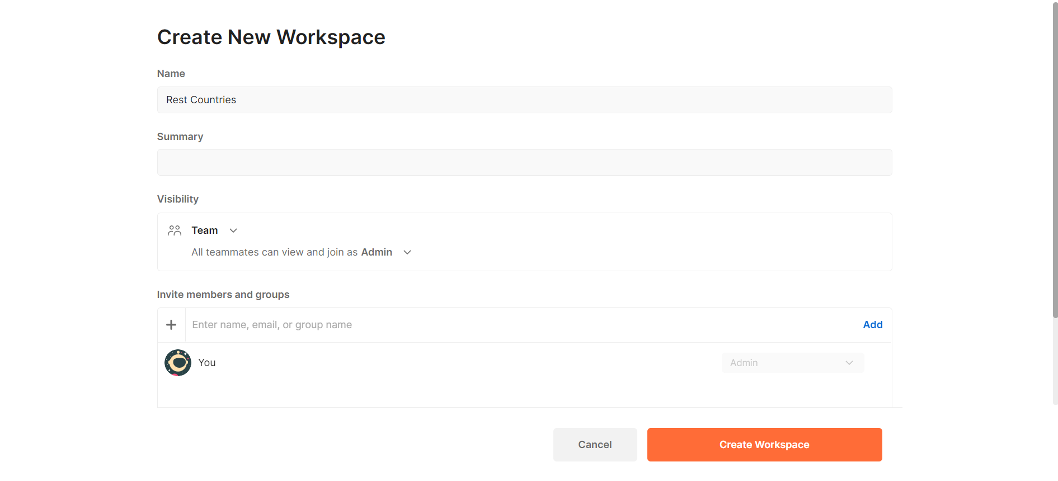

**Step 2 – Create new Collection**

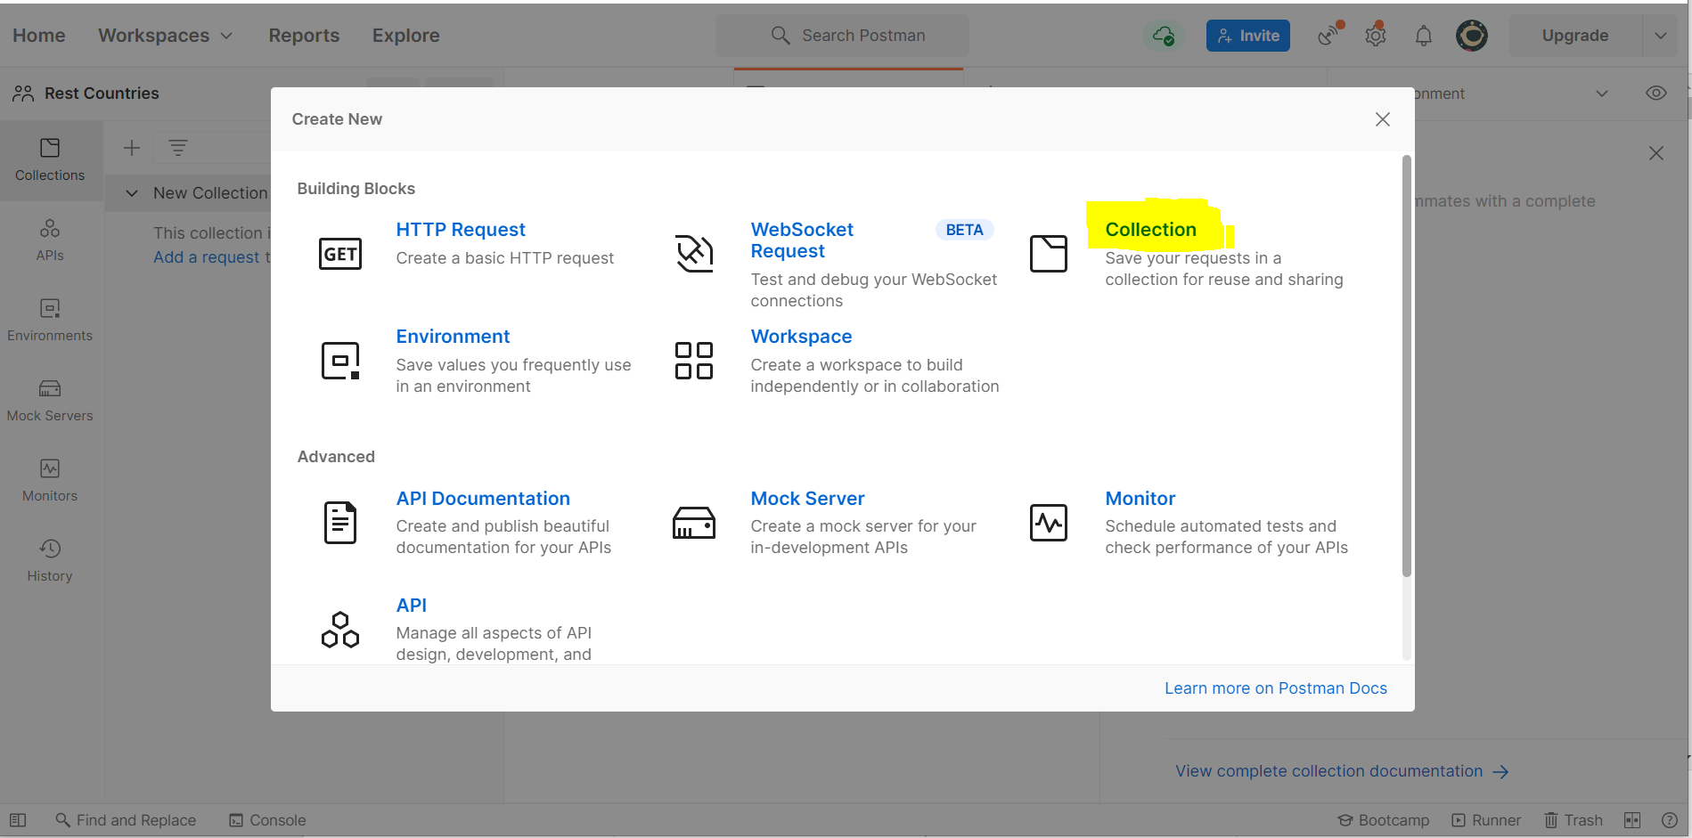

**Step 3 – Create new environment**

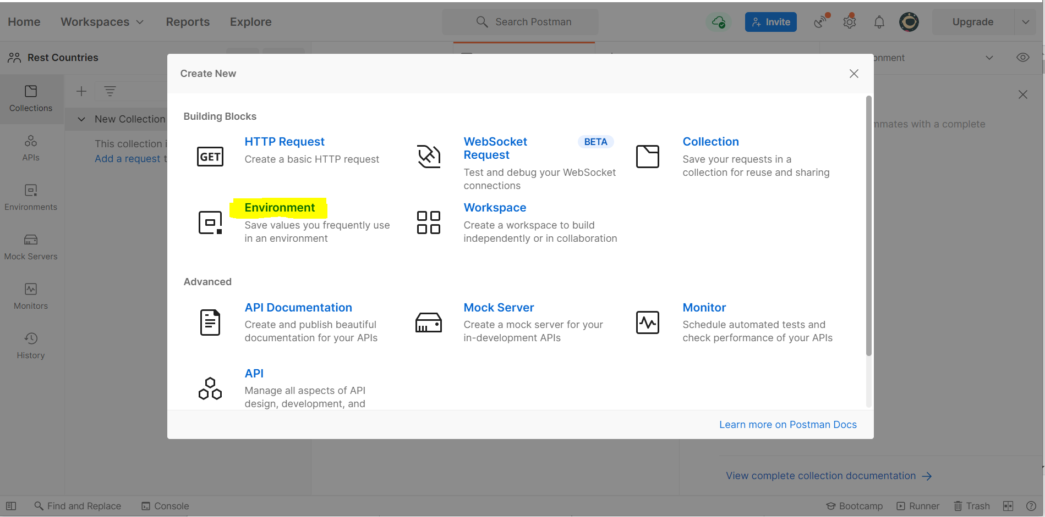

**Step 4 – Create New variables**

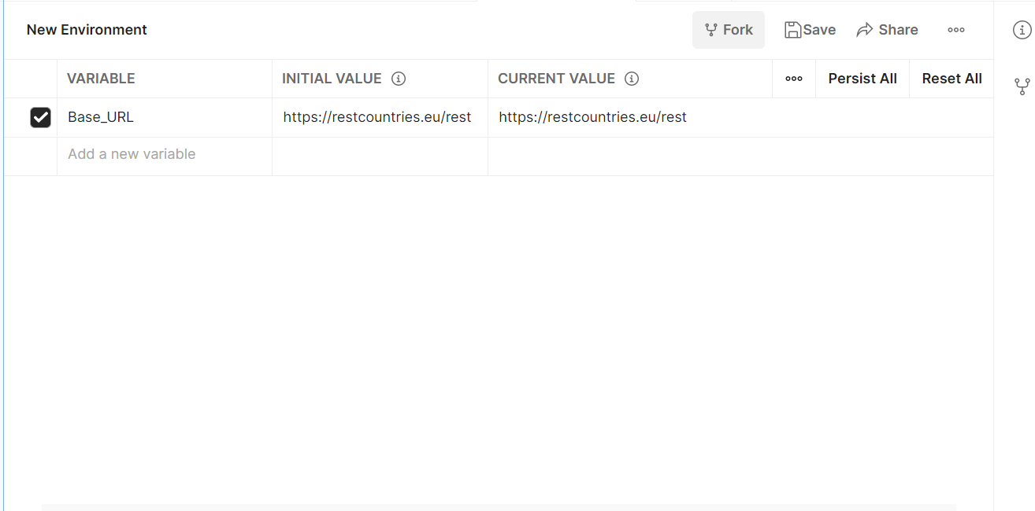

**Step 5 – Create New Request**

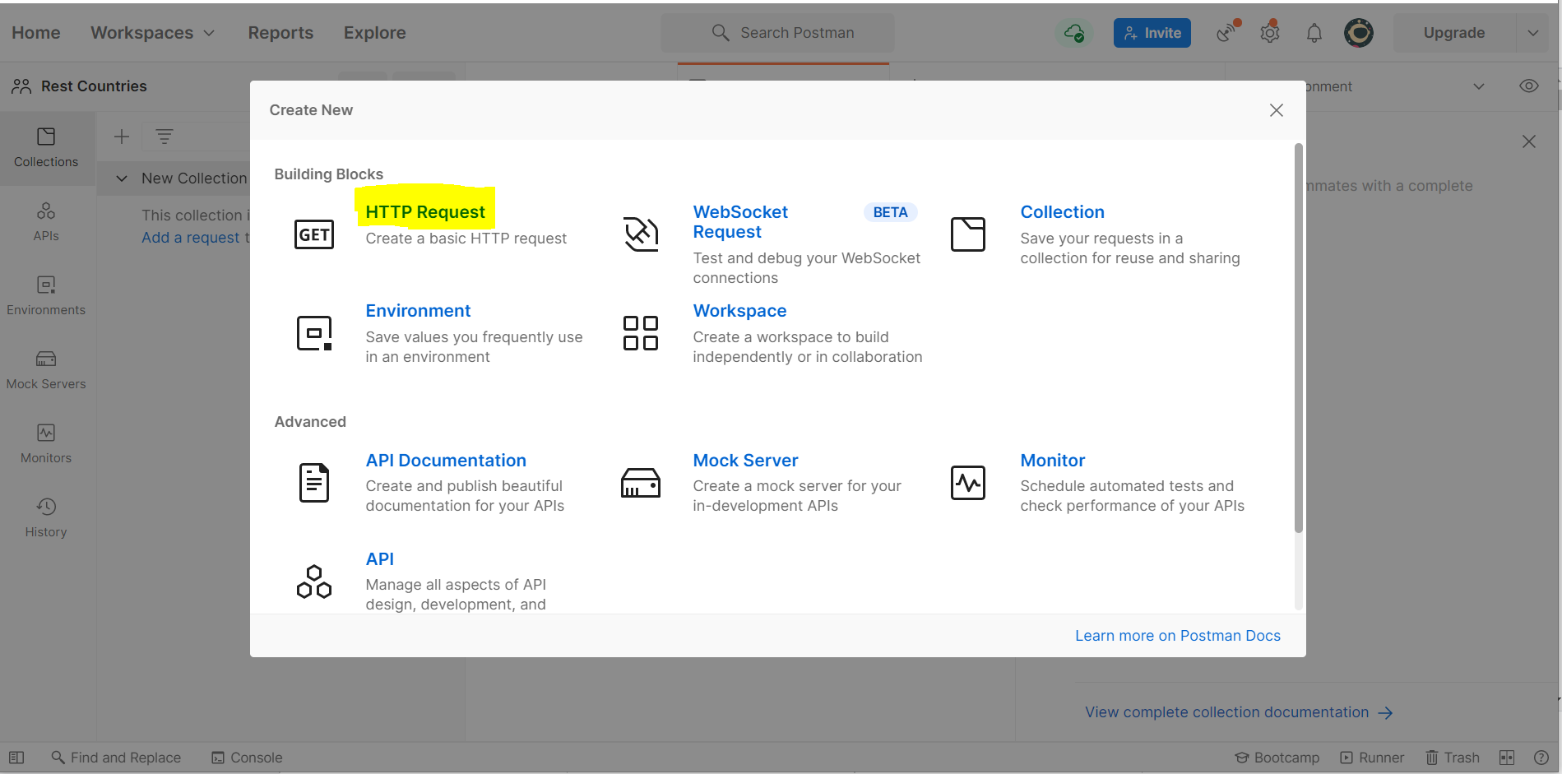

**Step 6 – Set Request Params**

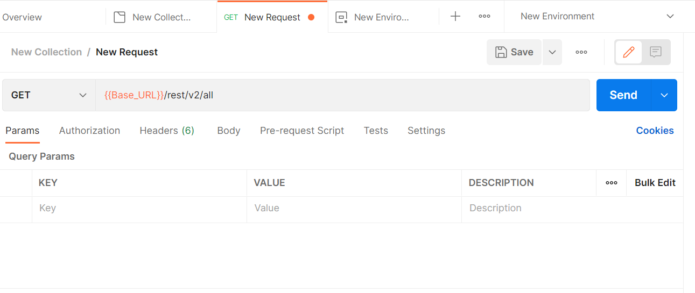

**Step 7 – Set Request Tests**

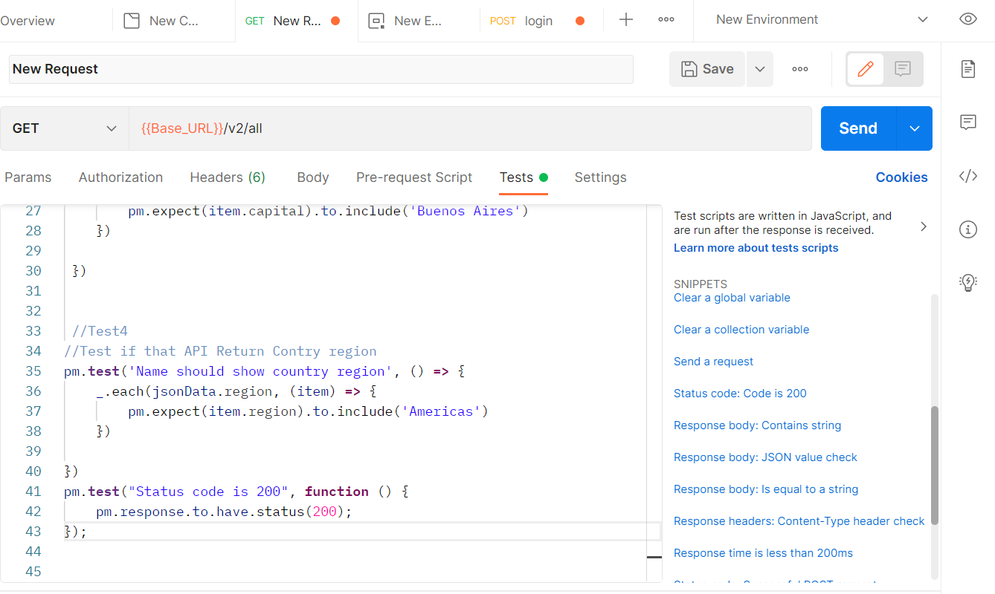

**Step 8 – Send Request**

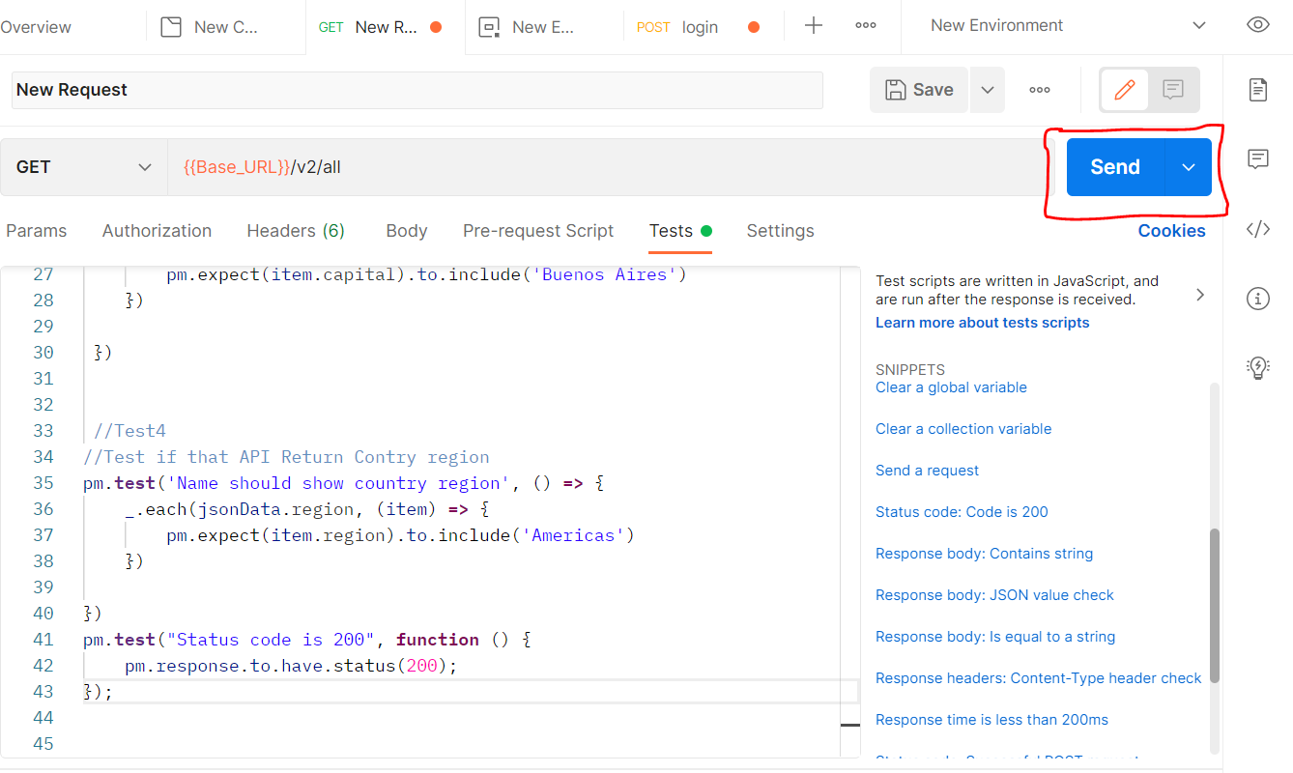

**Step 9 – Check Test Result**

